Local Initiative Support Corporation (LISC)
https://www.lisc.org
LISC, established in 1979, is a national organization dedicated to building affordable, livable, communities throughout the nation. LISC partners with Community Development Corporations in 37 urban communities and more than 150 rural communities in the USA, Puerto Rico, U.S. Virgin Islands, and Guam. LISC has invested a total of $32 billion as of 2023 including $2.4 billion in 2023. That investment has leveraged an additional $87 billion since 1979 and $5.3 billion in 2023. This has resulted in the construction or renovation of 506,302 affordable homes since 1979 including 18,273 in 2023. For any person or group interested in fostering long-term, capital intensive, positive development in an urban or rural community, LISC deserves your attention.
LISC’s 2025-27 Strategic Plan HERE includes the following graphic.
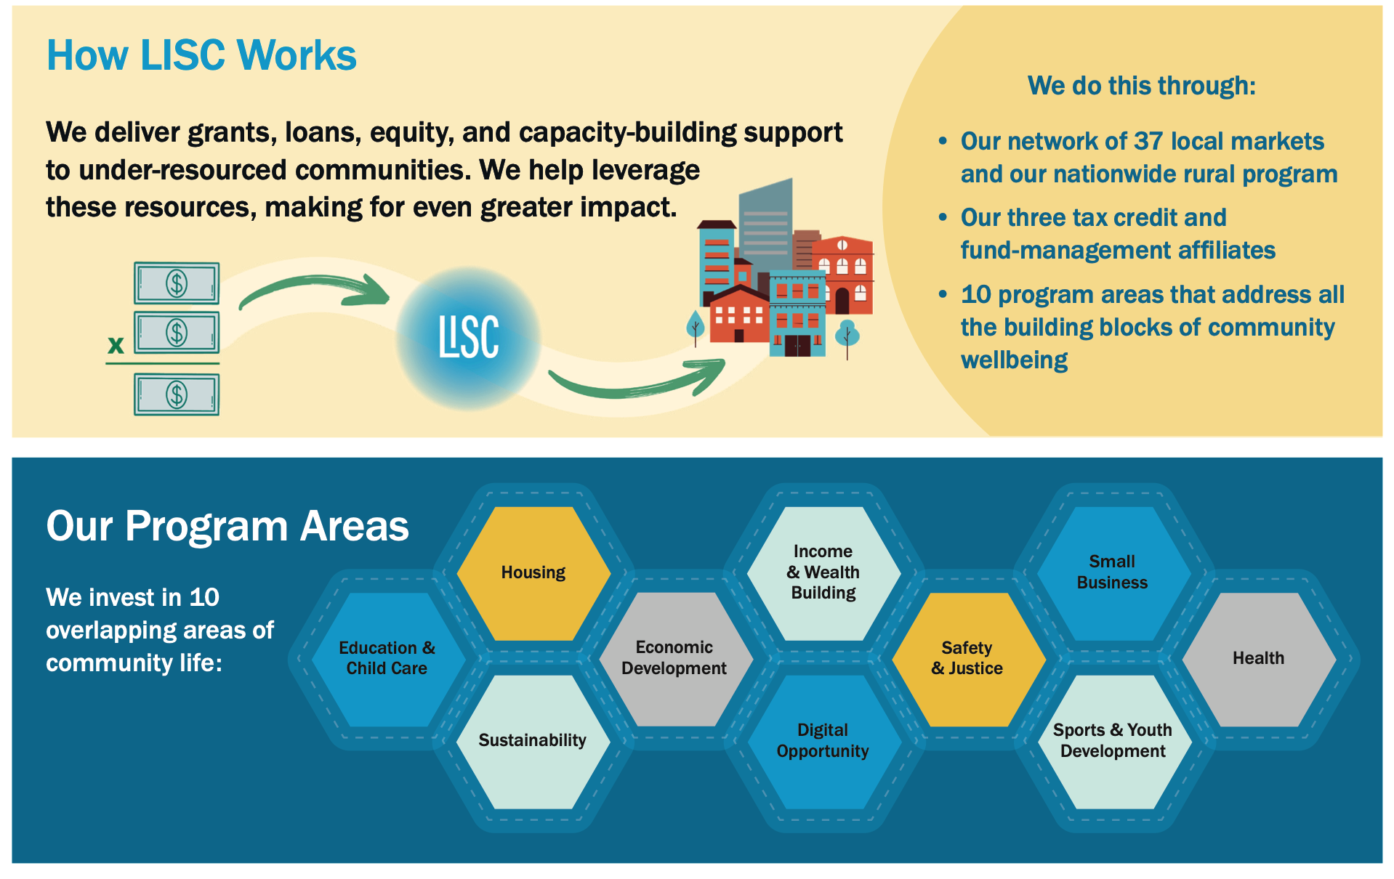
Details about LISC’s program areas are available at https://www.lisc.org/our-initiatives/.
LISC’s work in rural communities is described at: https://www.lisc.org/rural/.
The 2023 Annual Report at https://report.lisc.org/lisc-2023-annual-report/ includes a list of LIDC’s funding organizations. The largest category of funders, $5,000,000 - $10,000,000, includes Amazon, JPMorgan Chase, Verizon, and the Arthur M. Blank Family foundation.
Current (July 2025) initiatives to increase government funding for affordable housing are described at https://www.lisc.org/our-stories/.
What can LISC do in a typical urban area? The 2022-23 report for LISC Jacksonville, FL, can be found HERE. The following graphic in the report tells the story.
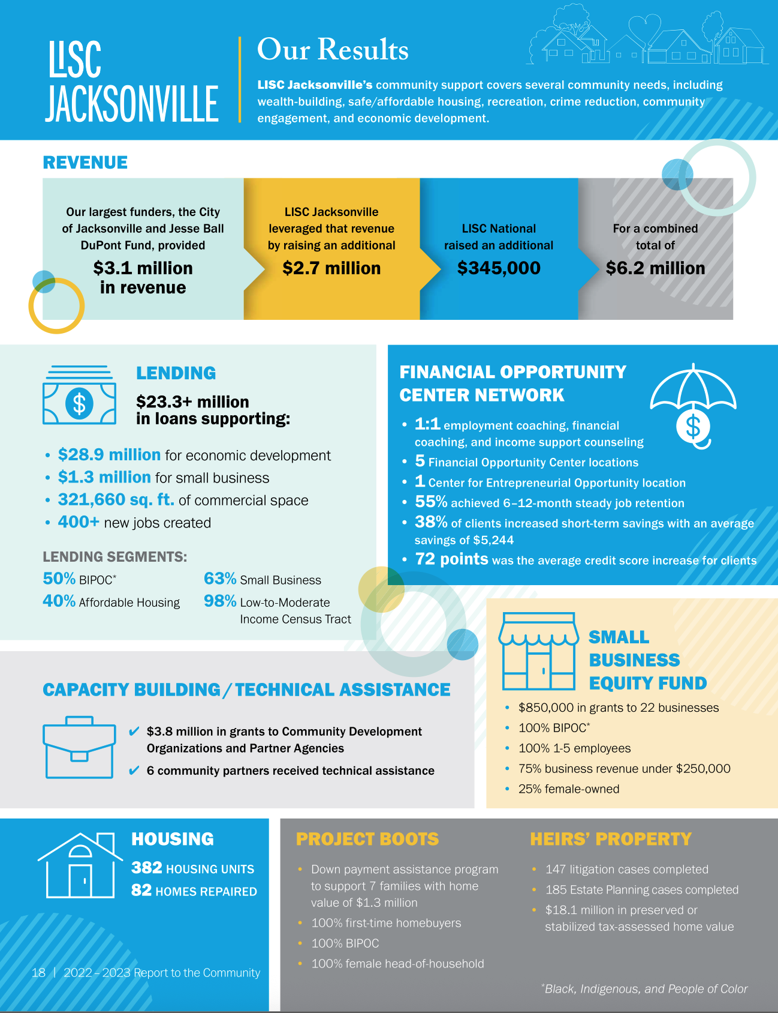
LISC contact information

LISC National Headquarters
28 Liberty Street, Floor 34
New York, NY, 10005
Tel: (212) 455-9800
Fax: (212) 682-5929
Press and media inquiries
Contact press@lisc.org. Scroll down for our digital press kit.
Corporate and philanthropic partnerships
Contact Deanna Hamilton, Senior Vice President of Development, at development@lisc.org.
Job opportunities at LISC
Please see our lists of current career and consulting opportunities.
Information about LISC program areas
Contact information for each of our national programs can be found within our program area pages. For local information, find a local LISC office near you.

