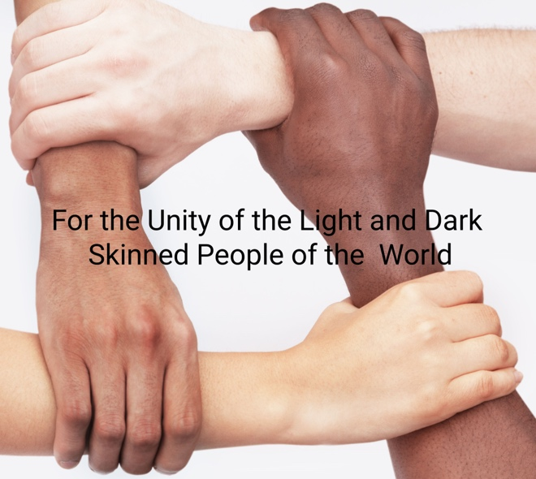

"WHITE PRIVILEGE" & MULTIRACIAL UNITY
A Convocation of the UU Multiracial Unity Action Council
Led by Dr. Kenneth Christiansen & Rev. Richard Trudeau
Saturday, Apr 13, 2024, Noon-1:30pm Central time
(Starts at 1:00pm Eastern, 11:00am Mountain, 10:00am Pacific)

TO REGISTER send an email to UUMUAC@gmail.com;
Zoom codes will be sent the day before

Part 1. The Term "White Privilege" -- Its Good & Bad Effects
“White Privilege” is a highly emotional term. It highlights racism and racial disparity. It can be everything from a discussion starter, to an empathy block, to a guilt wedge, to a blindfold in relation to the effects of CLASS.
--Discussion--

Part 2. Changing the Conversation
Whte Privilege can also be seen as an inventory of resources available for genuine antiracism work that collaboratively addresses discriminatory laws and policies.
--Discussion--

