The Direct Action & Research Training (DART) Center
https://thedartcenter.org

DART has 28 affiliated Church Based Community Organizations with Unitarian Universalist congregations participating in most of the affiliates. Twelve DART organizations are located in Florida where DART originated. Five are located in Kansas. Three in South Carolina. Two in Kentucky and Virginia. And one each in Indiana, Nebraska, Ohio and Tennessee. Contact information for each of the 28 affiliates can be found at https://thedartcenter.org/where-we-work/.

Some collective victories of DART organizations nationally include:
  - Over $450 million invested in affordable housing
  - Implementation of fair discipline policies in more than 650 schools, breaking the school-to-prison pipeline
  - Nearly $950 million invested in public transit
  - Criminal justice reforms resulting in 60,000 fewer arrests of children in Florida since 2014.
All affiliates are separate entities with their own name, acronym, and 501c3 number. The national organization provides the following:
- Guidance on starting up a new organization
- Ongoing consulting on power building, issue campaigns, fundraising, listening processes, and negotiations
- Recruitment of professional organizing staff
- Intensive training for new organizers through the Organizer’s Institute
- Three annual organizer trainings to continually build the skills and capabilities of professional organizing staff
- Planning and developing regional, national, and virtual trainings for local clergy and lay leaders

All DART organizations follow a yearly cycle. I (Ken Christiansen) will use ICARE (Interfaith Coalition for Action, Reconciliation and Empowerment) in Jacksonville, FL, as an example.
Listening Process
All 38 ICARE congregations hold one or more House Meetings in September and October. Goals of the Listening Process include:
- to build relationships around our concerns for justice;
- to listen to each other’s stories;
- to make a record of the stories for use when developing citywide strategies;
- to learn about how ICARE works; and
- to recruit Justice Ministry Network members.
The listening process culminates at the Community Problems Assembly in late October or early November where the issue focus for the year is determined.

Research Process
Issue Research Committees form or regroup at the Research Kickoff in December. Issue committees do the digging which includes:
- Refine the problems to identify specific solutions we feel will make a difference;
- Research where else in the nation this issue has been tackled effectively. Call the people who were involved to learn as much as possible about their successes and failures.
- Make appointments with persons in decision-making positions locally to learn how they are dealing, or not dealing, with the problems we have identified. This can involve some tension.
- Do telephone interviews with leaders of national public interest organizations that have worked with this issue.
- Prepare the questions elected leaders and other public officials will be asked at the Nehemiah Assembly.
Nehemiah Action Assembly
THERE IS POWER IN NUMBERS.
Justice Ministry Network members are encouraged and motivated to invite family, friends, fellow church members, and anyone else. The ICARE Nehemiah Assembly is held in the sanctuary of the largest ICARE congregation which can seat more than a thousand people.
There is tension in our interactions with public officials at the Nehemiah Assembly. They come knowing what questions they will be asked. They come because we are their constituents. Our 38 congregations represent over 30,000 Jacksonville citizens. We are usually asking them to make specific changes in what they are doing. They have the questions in advance. They can say no or yes. They get two minutes to say whatever they want. We hold the microphone.
We continue to follow up through our Research Committees throughout the year as needed. We monitor agreements that have been made to make sure they are followed. Backtracking happens. We keep pushing.
Sometimes it takes multiple years before we see the changes for greater justice that we want to see accomplished. With the issue of Restorative Justice for Youths, it took eight years during which we not only convinced Jacksonville’s Duval County Sheriff to give Civil Citations to nonviolent youths rather than arresting them. The statewide coalition of DART affiliates convinced the Florida state legislature to enact Civil Citations for nonviolent youths into law. There is a 97% success rate of no recidivism for youths who complete the program which includes counseling and relationship building elements.

A recent ICARE Fact Sheet on the next page explains more of the work being done in Jacksonville. All 28 DART affiliated organizations have robust issue development that is responsive to the needs identified in the congregational listening process. Their information is accessible using the contact information on the page at https://thedartcenter.org/where-we-work/.

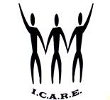
Interfaith Coalition for Action, Reconciliation and Empowerment (ICARE)
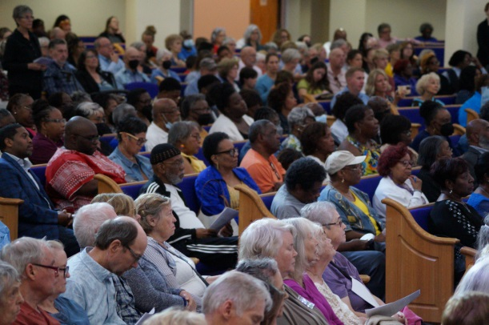
2650 Park St, Jacksonville, FL 32204
When we work together, great things happen!
Our Background: ICARE is a congregation-based organization formed in 1997. Our 38 congregations represent 30,000 people from different faith, racial, and economic backgrounds across northeast Florida. We are a non-profit, nonpartisan organization that powerfully addresses community problems by holding public officials accountable.
Past Successes
- Youth Arrest: ICARE got former Sheriff Mike Williams and State Attorney Melissa Nelson to use civil citations for minor, nonviolent misdemeanors like stealing a soda. Civil citations hold youth accountable without branding them with a permanent arrest record. This reduced youth arrest, saving our county $2.2 million each year. Many of the youth go to the Neighborhood Accountability Boards, another program ICARE got started. 97% of the youth who complete that program do not reoffend.
- Flooding: ICARE pressed city leaders to complete a Flood Vulnerability Assessment to address flooding. Because of this effort, Jacksonville is eligible for at least $100 million each year. The assessment was published in October 2023 and the Chief Resiliency Officer, Anne Coglianese, gave a report at our Nehemiah Assembly on April 15, 2024.
- Access to Mental Health Services: ICARE reduced the wait time for mental health services. At the Mental Health Resource Center, 50 more people each month are gaining access to mental health services because of the Open Access Program.
- Re-Entry Services: ICARE got our former Sheriff to increase the budget of the Jacksonville Re-Entry Center to $1 million dollars so they can offer better resources. Their programs lower the rate of people who reoffend after release.
- Data and Transparency: ICARE bolstered our former Sheriff and State Attorney Nelson to become national leaders in transparency by pushing them to share important data with the public. These officials now report prosecution statistics, homicides, use of force policies and more on their websites.
- School Discipline: ICARE got Duval Superintendent to increase the use of restorative practices from 9% to 41%. Out of school suspensions were cut in more than half – we went from 9,000 to 4,000.

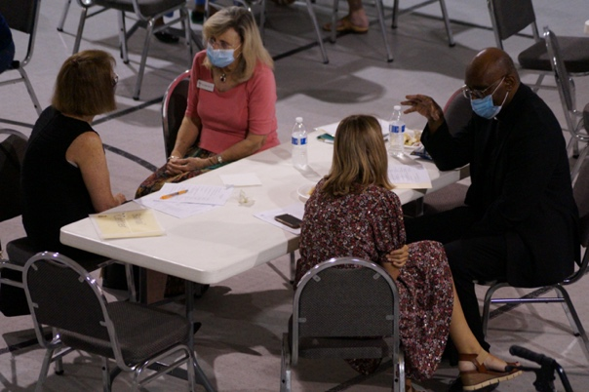
Current Areas of Focus
We are working to reduce homicides with a nonpartisan, evidence-based solution called Group Violence Intervention. We are also working to expand civil citations to adults. In other Florida communities, civil citations have been less expensive and better at holding adults accountable. Adults who receive a civil citation have to complete a program in order to avoid facing a criminal record. They are less likely to reoffend. At our Nehemiah Assembly on April 17, 2023 Sheriff TK Waters committed to assign his 911 coordinator to the task force of a new, 24/7 mental health crisis hotline called 988. He also committed to visit Miami to learn more about the Criminal Mental Health Project, which has successfully diverted thousands of people with mental illness from jail and saved their county millions of dollars.

Contact us at icarejax@gmail.com or by calling 904-388-9181. Follow us on Facebook: https://www.facebook.com/icarejacksonville

